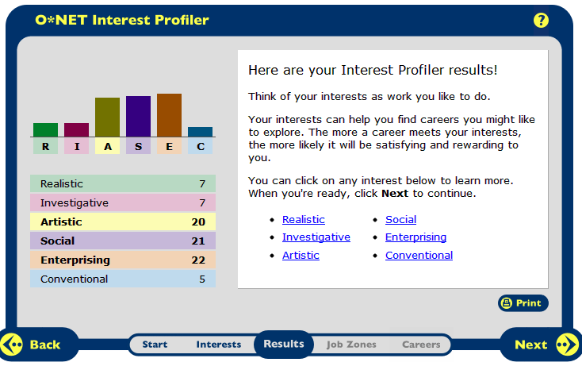
My top three interest groups are Artistic, Social, and Enterprising. I agree with these results. The definition of the Artistic group is people who like work that deals with the artistic side of things, such as acting, music, art, and design. I love to design and redecorate my room so I agree with the artistic interest.
My second top interest was Social. The interests of socials are they like working with others to help them learn and grow. They like working with people more than working with objects, machines, or information. I agree with this interest too because I love helping out younger kids and right now I think I want to be a kindergarten teacher.
My third top interest was Enterprising. People with Enterprising interests like work that had to do with starting up and carrying out business projects. These people like taking action rather than thinking about things. I don’t really agree with this one even though this was my highest interest. I don’t think I’d like to start my own business but I’d rather figure it out myself rather than have it explained to me.
Enterprising Social Artistic
- Cosmetologist | - Kindergarten Teacher | - Fashion Designer
- Real Estate Agent | - Pre-School Teacher | - Floral Designer
- Hair Stylist |  | - Model

Colleges
Personality Type | Job | School | Location | Website
Enterprising | Cosmetologist | Empire Beauty School | Providence, Rhode Island | www.Empire.edu
Enterprising | Cosmetologist | Cosmix School of Beauty Sciences | Marlborough, Massachusetts | www.cosmixbeautysciences.com
Enterprising | Real Estate Agent | Not needed | Not needed | Not needed
Enterprising | Hair Dresser | Empire Beauty School | Providence, Rhode Island | www.Empire.edu
Enterprising | Hair Dresser | New England Hair Academy | Malden, Massachusetts | www.newenglandhairacademy.com
Social | Kindergarten Teacher | Bridgewater State University | Bridgewater, Massachusetts | www.bridgew.edu
Social | Kindergarten Teacher | Worcester State University | Worcester, Massachusetts | www.worcester.edu
Social | Preschool Teacher | Bridgewater State University | Bridgewater, Massachusetts | www.bridgew.edu
Social | Preschool Teacher | Worcester State University | Worcester, Massachusetts | www.worcester.edu
Artistic | Fashion Designer | School Of Fashion Design | Boston, Massachusetts | www.schooloffashiondesign.org
Artistic | Fashion Designer | The Art Institute | Brookline, Massachusetts | www.artinstitutes.edu
Artistic | Floral Design | Rittners School of Floral Design | Boston, Massachusetts | www.floralschool.com
Artistic | Floral Design | Cass Flowers Design School | Watertown, Massachusetts | www.cassflowers.com
Artistic | Model | You Model and Act.com | Boston, Massachusetts | www.youmodelandact.com
Artistic | Model | Barbizon Modeling | Boston, Massachusetts | www.barbizonmodeling.com

Career Research Data for 8 Career Occupations
Career Research Questions: | Cosmetologist: | Real Estate Agent: | Hairstylist: | Kindergarten  Teacher: | Pre-School  Teacher:
HR1. Occupation Definition | Provide hair styling and beauty services. | Help clients buy, sell, and rent properties. | Provide hair styling services. | Prepare younger students for future schooling. | Educate and care for children 3 to 5.
HR2. Related Occupations | Hair dressers, barbers, skincare specialists | Loan officers, insurance sale agents | Manicurists and Pedicurists | Childcare workers, librarians | Childcare workers, teacher’s assistant
HR3. Compatible Personality Types | Enterprising | Enterprising | Enterprising | Social | Social
HR4. Education/Training/Qualifications Required | High School Diploma | High School Diploma or equivalent | Some require high school diploma others beauty school | Bachelor’s degree | Associate’s degree
HR5. Technology Skills Needed | Skills for booking appointments and/or advertising | Different types of Microsoft programs | Varies | Spreadsheets, e-mail, word processing, along with basic internet skills | Basic internet skills, e-mail, spreadsheets, word processing
RC1. Entry Level Average Salary | $22,500 a year | $42,680 a year | $22,500 a year | $51,380 a year | $25,700 a year
RC2. 10 yr. Projected Job Growth | 14% increase | 11% increase | 14% increase | 17% increase | 25% increase
RC3. Organizations that hire for this occupation | None | Remax | None | Local schools | Local preschools and daycare centers
ISC1. Working Conditions | 12 hours per day in a Salon or Spa. Average pay is 10.82 per hr. | 40 hours per week. Most work in brokerage offices. | Mostly salons some work in spas, hotels, resorts,etc. | Teachers usually work 5 days a week from the time students arrive until they leave. | Most preschools teacher work in childcare centers from generally 9 a.m. to 3 p.m.
ISC2. Part of a Union | No | No | No | National Education Association | National Education Association
ISC3. What kind of Advancement Opportunities are there? | If working for someone there is chance for promotion. | No | If working for someone there is a chance for promotion. | If you want to become an administrator there are certain classes and requirements you must meet to be promoted. | You could become a lead teacher or come to own your own childcare business.
Universities/Colleges/Specialized Training Organizations | Empire Beauty School or Cosmix School of Beauty Sciences | None needed | Empire Beauty School or New England Hair Academy | Bridgewater State University or Worcester State University | Bridgewater State University or Worcester State University

Career Research Data for 8 Career Occupations
Career Research Questions: | Fashion Designer: | Floral Designer: | Model:
HR1. Occupation Definition | Fashion Designers create original clothing, accessories, and footwear. | Florists cut and arrange live, dried, or silk flowers and greenery to make decorative displays. | Advertise a variety of products.
HR2. Related Occupations | Graphic designers, floral designers, art directors, and models. | Interior design, fashion designers, and graphic designers. | Actors, hair dressers, and photographers.
HR3. Compatible Personality Types | Artistic | Artistic | Artistic
HR4. Education/Training/Qualifications Required | A high school diploma or equivalent | A high school diploma | Less than a high school diploma
HR5. Technology Skills Needed | I couldn’t find any specific skills needed | Communication skills | General communication skills
RC1. Entry Level Average Salary | $64,530 a year | $23,610 a year | $32,920 a year
RC2. 10 yr. Projected Job Growth | 0% (little or no change) | 9% decrease | 14% increase
RC3. Organizations that hire for this occupation | Local clothing stores | The Society of American Florists helps find jobs. | None
ISC1. Working Conditions | Most designers travel to other countries for supplies, the final product, or fashion shows. Most work long hours due to deadlines. | Most work in floral shops. Florists may work longer hours during the holidays. | Models work in different environments. Most have unpredictable schedules and must be ready to work at all times.
ISC2. Part of a Union | Council of Fashion Designers in America | No | Mannequins and Models Division of the Shop
ISC3. What kind of Advancement Opportunities are there? | Advancement would be becoming a well-known fashion designer. | You may work your way to owning your own business. | There isn’t really a chance to be promoted but going from a local level to an international level is advancement.
Universities/Colleges/Specialized Training Organizations | School of Fashion Design or The Art Institute | Rittners School of Floral Design or Cass Flowers Design School | YouModelandAct.com or Barbizon Modeling

